Food pack hips plastic sheet

The greatest specific use of HIPS is as packaging and disposable materials, especially food packaging materials and tableware. The main applications include daily packaging containers

PS material, environmental protection and hygiene. Through SGS, ISO 9001 certification. PS density is small and easy to shape, safe and non-toxic to ensure that 100% of raw materials can be directly contacted with food. It is often used to make bowl-packed instant noodle boxes, snack boxes, disposable food packaging boxes, etc. It has good cold resistance.

Food grade PS sheets are often used in yogurt cups and other containers. It is heat-resistant and cold-resistant, but can not be put into the microwave oven to avoid releasing chemicals due to excessive temperature.

Now our company—Zibo Tianheng New NanoMaterials Technology Co., ltd have 3 HIPS&PP production line can guarantee your purchase demand.

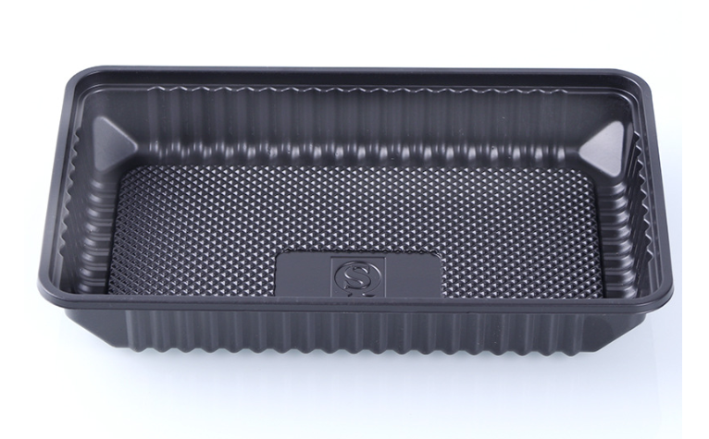
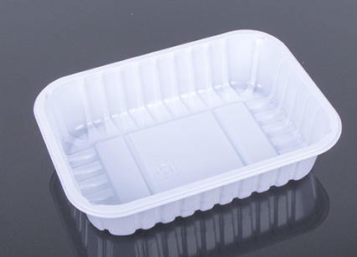
Main application | Specification | Thickness  (mm) | Width  (mm)
Food Grade | Applicate to Yogurt cup, food packaging tray,pharmaceutical and health products packaging tray. | 0.20~1.80 | 450~800

Our production manager has rich production experience, stable and reliable formula. We will offer you price according to your detail request, so please kindly inform us of the material, thickness, size, printing area and other requirements you prefer, then the best price will be given. We can produce various packaging bags& packaging films as per your requirements, if necessary, we can also provide you free samples
